KYC Case Study Functionality Testing Document
(Fundamentals of Blockchain and Smart Contracts Case study
Graded Assignment)

Assignment : KYC Case Study
Submission to : Upgrad
submitted by :Chandrashekhar Satav

- KYC Use Case
The source for the specifications of detailed KYC Case study is provided in the assignment module of course 6(Fundamentals of Blockchain and Smart Contracts).
KYC Use Case Block Diagram
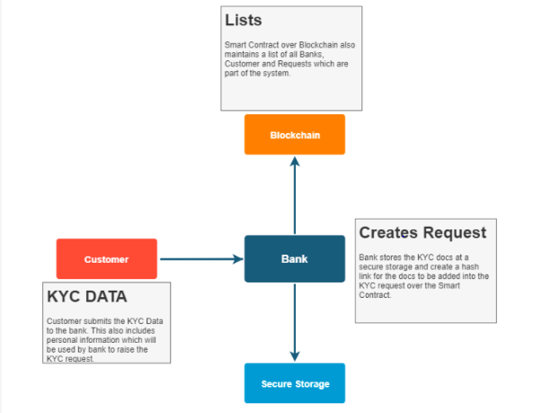

Testing Environment : Remix Ide in an online Environment : Plugins - solidity complier, Deploy and Run Transactions

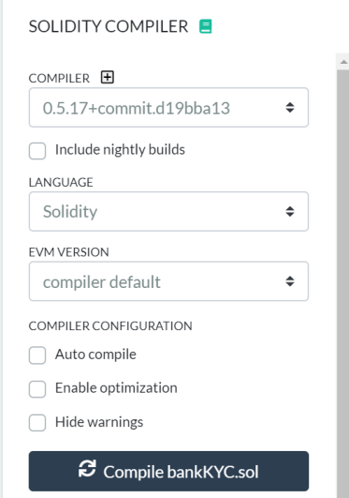 | 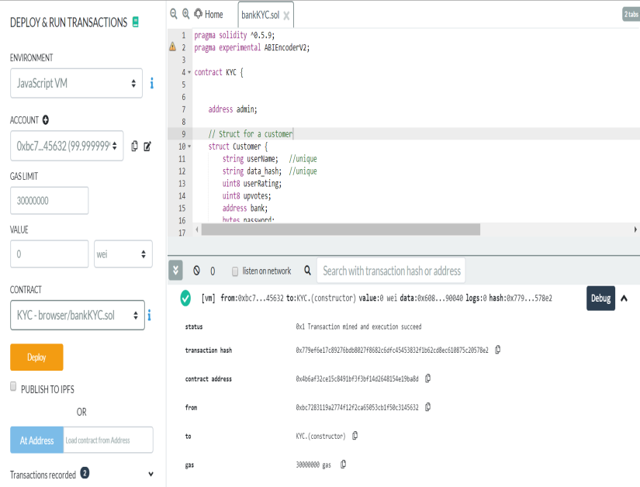
- List of functions

S.No | Name of the function
1 | Add Bank
2 | Remove Bank
3 | upvoteBank
4 | getBankRating
5 | getBankDetails
6 | BankCount
7 | addKYCRequest
8 | removeKYCRequest
9 | getBankInitiatedKYCRequest
10 | addCustomer
11 | removeCustomer
12 | setPassword
13 | viewCustomer
14 | upVoteCustomer
15 | getCustomerRating
16 | modifycustomer
17 | getAccessHistory

1. compile the smart contract

The smart contract compiled successfully with one warning because of using abi experimental

2. Deploy the smart contract

Admin Adress: 0xbc7283119A2774F12f2ca65053Cb1F50C3145632

3. addBank

Functionality | Remarks
This function is used by the admin to add a bank to the KYC Contract. You need to verify if the user trying to call this function is admin or not. | 1.Added 4 banks successfully  2.when non-admin is trying to add, an error message is prompted  3.If the bank is already added, then an error message is prompted

msg.sender(admin) | Bank Name | Bank Address | Bank Registration No | Remarks
0xbc7283119A2774F12f2ca65053Cb1F50C3145632 | Bank 1 | 0xFC51b3F69870e8f75f80528BbcD75A3D5Ff0b028 | 001 | Banks added successfully
0xbc7283119A2774F12f2ca65053Cb1F50C3145632 | Bank 2 | 0xAB43B66a28F8Aa7440b8175008D94F51F09ad9FB | 002 | Banks added successfully
0xbc7283119A2774F12f2ca65053Cb1F50C3145632 | Bank 3 | 0x08926701D4B9E4e7FF2E6a5F31D760906f83a136 | 003 | Banks added successfully
0xbc7283119A2774F12f2ca65053Cb1F50C3145632 | Bank 4 | 0x8638E4babf10d96D5a1c91364B7Ba89c1d1a5e96 | 004 | Banks added successfully

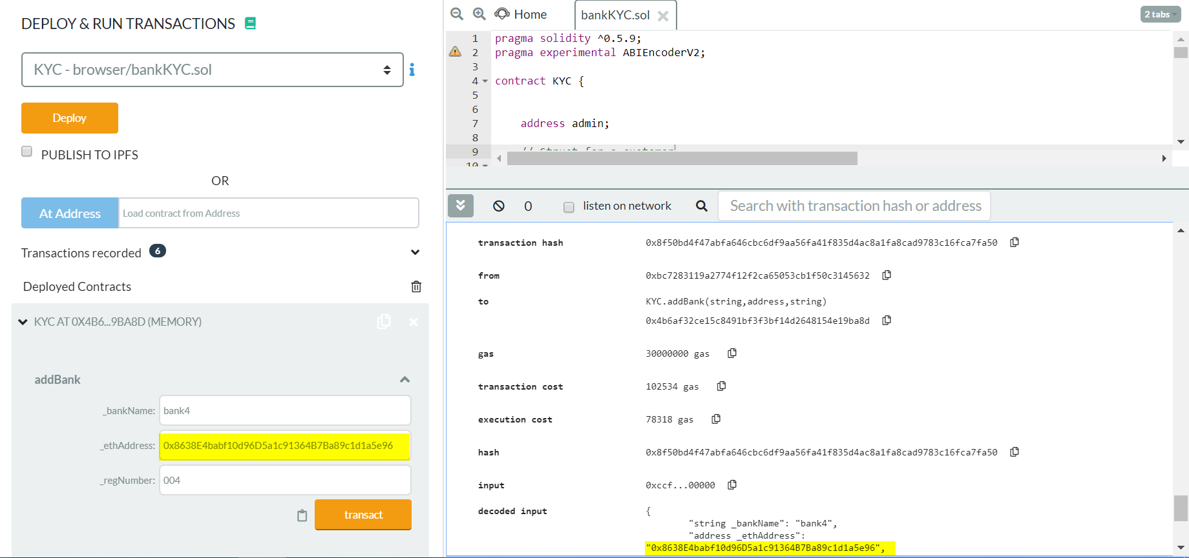

Bank1 (non -admin) is trying to add Bank4 an error message is prompted

When tried to add existing Bank,
It gives an error message “The Bank is already present”

4. removeBank

Functionality | Remarks
This function is used by the admin to remove a bank from the KYC Contract. You need to verify if the user trying to call this function is admin or not. | 1.removed bank successfully  2.when non-admin is trying to remove the bank, an error message is prompted  3.If the bank address doesn’t exist, then an error message is prompted

msg.sender(admin) | Bank Address | Remarks
0xbc7283119A2774F12f2ca65053Cb1F50C3145632 | 0x51bF7DA134Ae3090CeA045f71096696D26F1411d | bank removed successfully
0xFC51b3F69870e8f75f80528BbcD75A3D5Ff0b028 | 0x51bF7DA134Ae3090CeA045f71096696D26F1411d | Only admin can add remove bank
0xbc7283119A2774F12f2ca65053Cb1F50C3145632 | "0x51bF7DA134Ae3090CeA045f71096696D26F1411i" | Error: invalid address

remove the Bank004 with address 0x51bF7DA134Ae3090CeA045f71096696D26F1411d

Bank002(non admin) is trying to remove the Bank005 : Error message is prompted

Trying to remove the Bank005 whose address is not found : Error message is prompted

5. upvoteBank
Functionality | Remarks
This function is used to add and update votes for the banks. You also need to update the rating for the bank in this function. If the bank has already voted for the same bank before, reject the request. | 1. Bank upvotes successfully  2. Bank voted for the same bank, an error messag e is prompted  3.If the bank address doesnt exist, then an error message is prompted  4. A Bank cannot upvote its own bank, then an error message is prompted

6. getBankRating
Functionality | Remarks
This function is used to fetch bank rating from the smart contract | 1.fetched bank rating successfully  2. If the bank address doesnt exist, then an error message is prompted

BankRating for Bank 002:
Note : Bank001 has voted

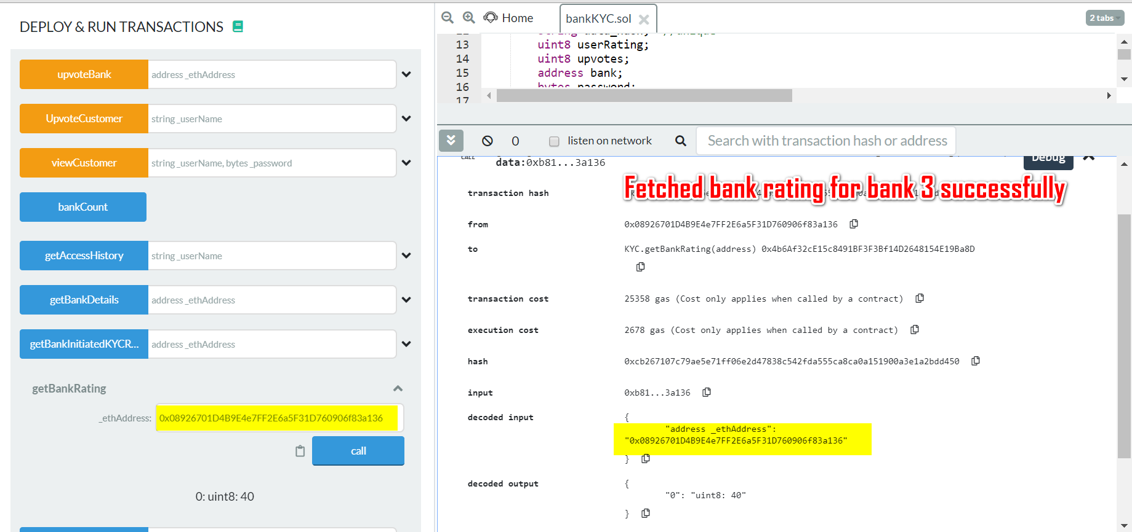

7. getBankDetails

Functionality | Remarks
This function is used to fetch the bank details. | 1.fetched bank details successfully  2. If the bank address doesnt exist, then an error message is prompted

14. setPassword
Functionality | Remarks
This function is used to set a password for customer data, which can be later be unlocked by using the password. This required to give access to only certain banks. It could be a possibility that customers do not want to share his/her data with everyone. To make sure the customer data is protected, we add a password to customer data. While retrieving the information for customer, bank also needs to pass the password, if the password is set for the customer. If the password is not set then every bank can view the data. | 1. .If the userName is not found , then an error message is prompted  2. updated password successfully  3. If the password is already set, then it returns false
Cust001- PASSWORD = 0x1010101010101010
Cust002- PASSWORD= 0x10101010101010101

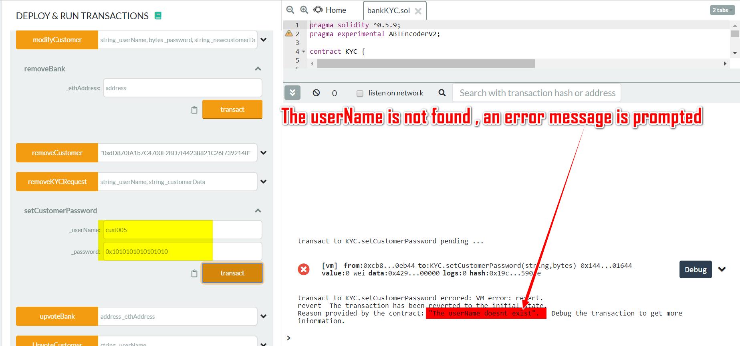

15. viewCustomer
Functionality | Remarks
This function allows a bank to view details of a customer | 1. If the userName is not found , then an error message is prompted  2. The customer has the password set, it should allow to view customer details  3. This customer password is not set and nothing has passed or an wrong password so an error message is prompted  4. Since the incoming password entered is "0" , the bank should be able to view the customer details

16. upvoteCustomer
Functionality | Remarks
This function allows a bank to cast an upvote for a customer. This vote from a bank means that it accepts the customer details as well acknowledge the KYC process done by some bank on the customer. You also need to update the rating for a customer in this function. The rating is calculated as the number of upvotes for the customer/total number of banks. If rating is more than 0.5, then you can add the customer to the final_customer list. If the bank has already voted for the same customer before, reject the request. | 1. If the userName is not found , then an error message is prompted  2.If the Bank has already voted , an error message is prompted  3.banks upvoted the custmers successfully

17. getCustomerRating
Functionality | Remarks
This function is used to fetch customer rating from the smart contract. | 1. If the userName is not found , then an error message is prompted  2.Fetched the bank rating successfully

18. modifyCustomer
Functionality | Remarks
This function allows a bank to modify a customer's data. Only applicable for the customers whose request have been validated and present in the customer list. If the user is present in the final customer list then remove it from the final list and change the upvotes and rating component of the customer in customer list to "0". Remove all the previous upvotes for the customer. Hence, banks need to again upvote on the customer to acknowledge the modified data. | 1. If the userName is not found , then an error message is prompted  2.modified the customer

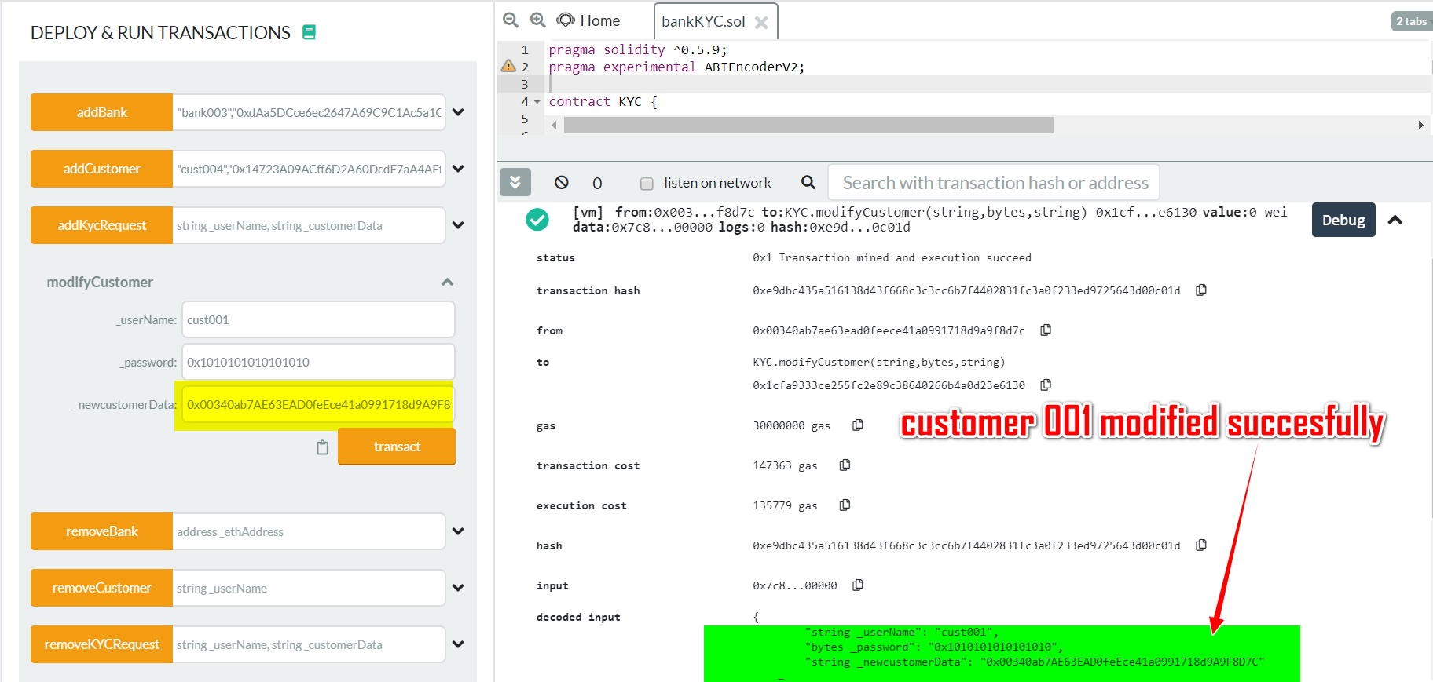
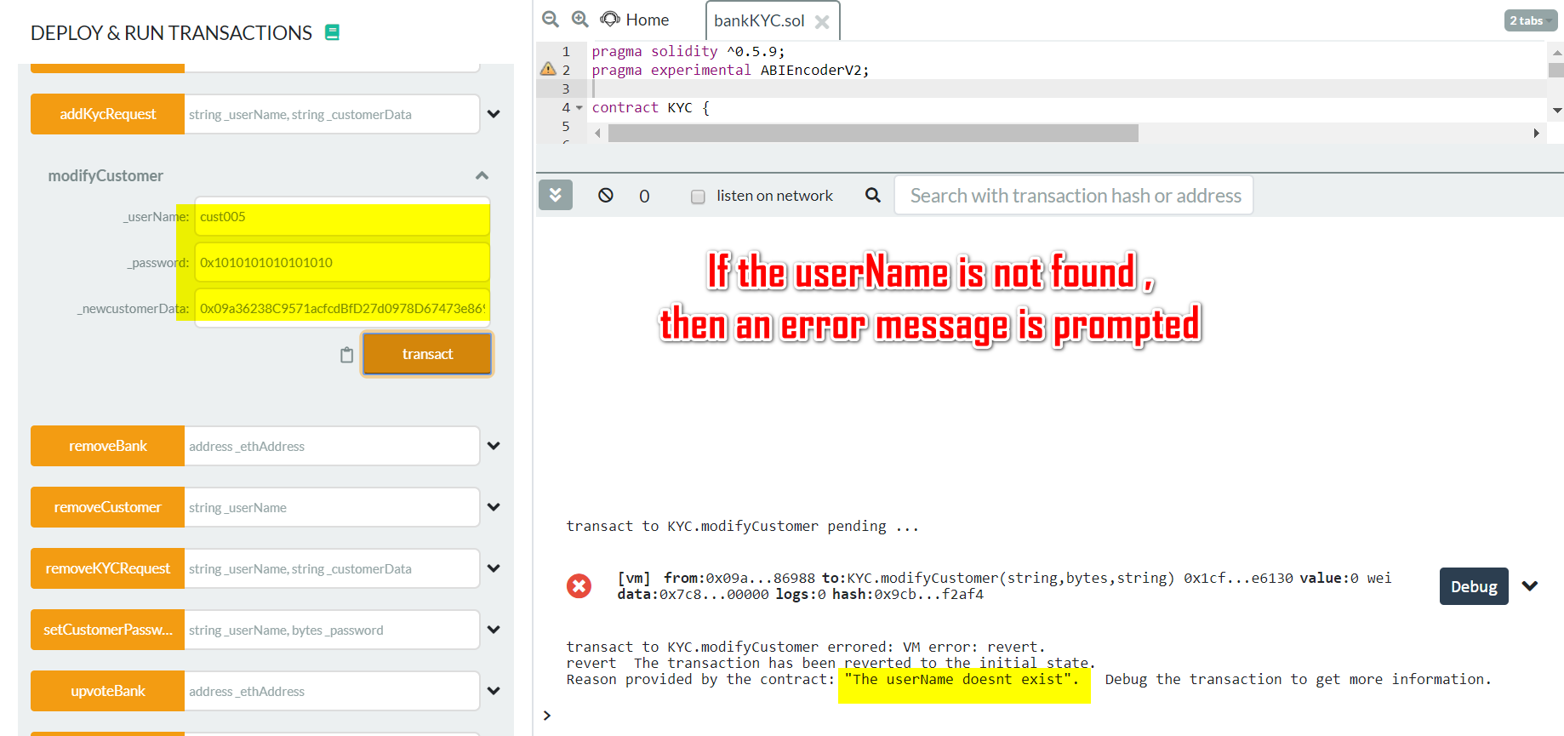

19. getAccessHistory
Functionality | Remarks
This function is used to fetch the bank details which made the last changes to the customer data. | 1. If the userName is not found , then an error message is prompted  2.on successful retrieval bank address is returned

Result : The functionality over multiple test checks is been done, and achieved as per the assignment expected results

References: Upgrade course content, udemy Tomweisner lectures, DAPP University Smart Contract Tutorials

